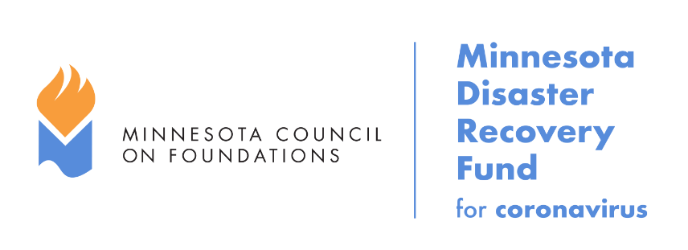

Overview
The Minnesota Disaster Recovery Fund (MDRF) was created to support community needs as a direct result of the coronavirus pandemic. The MDRF will provide grants to community intermediaries with a history of community assistance. Grants are intended for, but not limited to, addressing needs that arise for individuals and families due to the economic impact of coronavirus; addressing needs nonprofits are experiencing due to increased demand for services or social distancing recommendations and closures; and addressing needs small businesses are experiencing due to interrupted operations. The MDRF funds both short and long-term needs that arise within communities, due to coronavirus or future disasters that occur within the state of Minnesota.
eligibility
Eligible organizations are community intermediaries, such as local community foundations, Minnesota Initiative Foundations, tribal nations, community development financial institutions, coalitions, networks, associations, and other intermediaries who have the knowledge to address specific needs in their communities, as well as the ability to be nimble and responsive in times of emerging needs. These organizations must have an existing grant-making or fund distribution process in place to get funds to individuals and families, nonprofit organizations, and/or small businesses.
funding criteria
Funds will be awarded on an ongoing basis until further notice and grant awards will be based on competition of requests in relation to fund balance. Proposals will be considered weekly. The Advisory Committee may hold onto a proposal for consideration in the future, depending on other proposals received. Our intent is to keep the application process simple and concise.

The following criteria will be considered when reviewing the proposals:

- Coronavirus Impact. Requests should aim to support individuals and families, nonprofits, and/or small businesses to address needs specifically created by coronavirus and its economic impact on the community.
- Equity. The fund will provide special consideration to requests that focus on populations impacted by coronavirus that were already experiencing structural inequities prior to the pandemic. Inequities can be exacerbated by disasters, and the fund will provide special consideration to supporting marginalized communities that may be hardest hit and face a steeper road to recovery (low-income, black, indigenous and people of color, undocumented, rural, LGBTQ, disabled, etc.) Note: This list is not meant to be exhaustive of what equity considerations may look like in the context of coronavirus.

- Community Recovery Focus. This fund is focused on supporting individual and whole community recovery from the pandemic. This fund is not meant to fund government or supplies or other medical responses. Recovery can take a long time, so the Committee will look to fund both short and longer-term recovery efforts.
- Unmet needs. Could this need be met by a federal or state program or by other funds designed for coronavirus recovery? This Fund will be used to meet unmet needs, not duplicate or fund programs that other larger funding programs could cover. Requests that reach groups that might not have access to resources otherwise will be prioritized.
Advisory Committee members will also consider the total mix of grantees to ensure a statewide response that includes individuals/families, nonprofits, and small businesses. Grantees will be required to submit a brief narrative report and itemized budget at the conclusion of the grant.

timelines and submission information
Proposals submitted by 12:00 p.m. noon on Wednesday, will generally be reviewed on the following Friday. Proposals should be 1-3 pages in length and emailed to coronavirusfund@mcf.org.

Grant Application Proposal
Directions: Complete the organization information and proposal in the sections below. The proposal section indicates word counts which should be used as a guide to ensure simple and concise information is received. All applicable sections must be completed for MDRF proposal consideration.

organization information
Name of Organization:
Address:
City:
State:
Zip:
Phone:
Employer ID #:
Is your organization a 501(c)3? (Yes or no):
Is your organization a public agency/unit of government/tribal nation? (Yes or no):

organization point of contact
Full Name:
Title:
Phone:
Email Address:

grant wire transfer contact
If awarded, grant funds will be distributed via wire transfer. Please let us know who within your organization will be the point of contact to manage wire transfers and grant fund processing.

Full Name:
Title:
Cell:
Email Address:

proposal information
- Describe your role as a community intermediary. How does your organization support individuals and families, nonprofit organizations, and/or small businesses? (250 words)
Note: Please see definition of community intermediary (page 1) to see if you are eligible.
- Describe the impact(s) of Covid-19 on your community. How do you plan to address this impact(s)? (500 words)

- Provide a brief summary of your request. (2-3 sentences)
- What geography and population will you be serving? (250 words)

- What is the amount requested?
- What gap will this fill? Are there other funds that could be leveraged to serve this need?
(250 words).
Note: Leveraging funds is not a requirement. This fund is not intended to supplant government funding.
- Describe your method(s) of redistributing resources. What is your timeline for redistributing funds? (250 words)

email completed application proposals to: coronavirusfund@mcf.org
Questions? Email the Minnesota Council on Foundations at coronavirusfund@mcf.org | mcf.org/MDRF

